// Assignment no-6

/\*PROBLEM STATEMENT:-

6. Write an Embedded C program to interface PIC 18FXXX with LED & blinking it using specified delay.

\*/

//Source Code:-

#include <xc.h>

#include <stdlib.h>

#include<pic18f4550.h>

void TODELAY(void);

void main(void)

{

TRISD =0x00;

while(1)

{

PORTD =0xFF;

TODELAY();

TODELAY();

PORTD=0x00;

TODELAY();

TODELAY();

}

}

void TODELAY()

{

T0CON=0x08;

TMR0H=0x35;

TMR0L=0x00;

T0CONbits.TMR0ON=1;

while(INTCONbits.TMR0IF==0)

{

}

T0CONbits.TMR0ON=0;

INTCONbits.TMR0IF=0;

}

\*\*\*\*\*\*\*\*\*\*\*\*\*\*\*\*\*\*\*\*\*\*\*\*\*\*\*\*\*\*\*\*\*\*\*\*\*OUTPUT\*\*\*\*\*\*\*\*\*\*\*\*\*\*\*\*\*\*\*\*\*\*\*\*\*\*\*\*\*\*\*\*\*\*\*\*\*\*

1)I/O VIEW

A]PORTD=FF AND 00

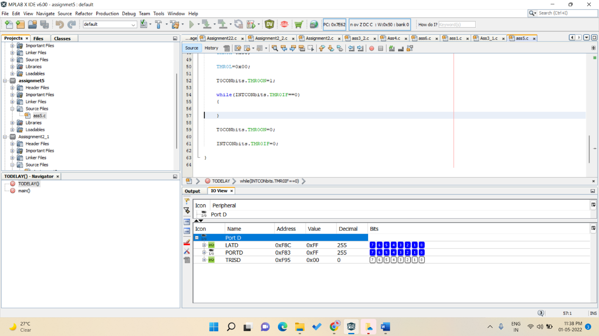

B]PORTD=55 AND AA

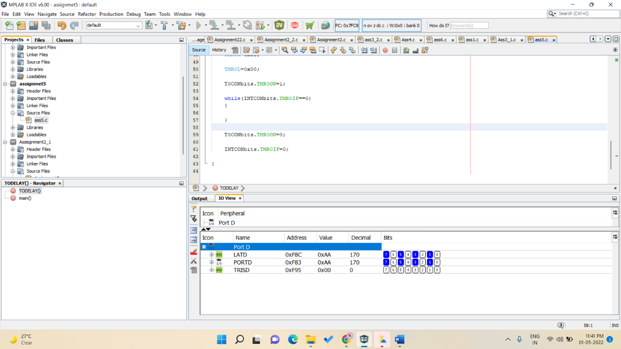

2)PICSIMLAB OUPUT

A]PORTD=FF AND 00

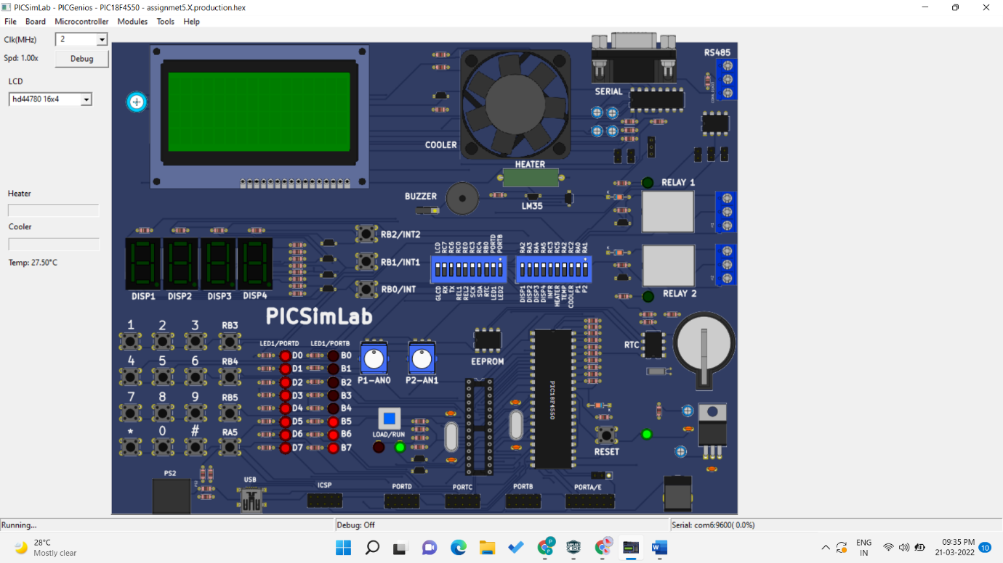

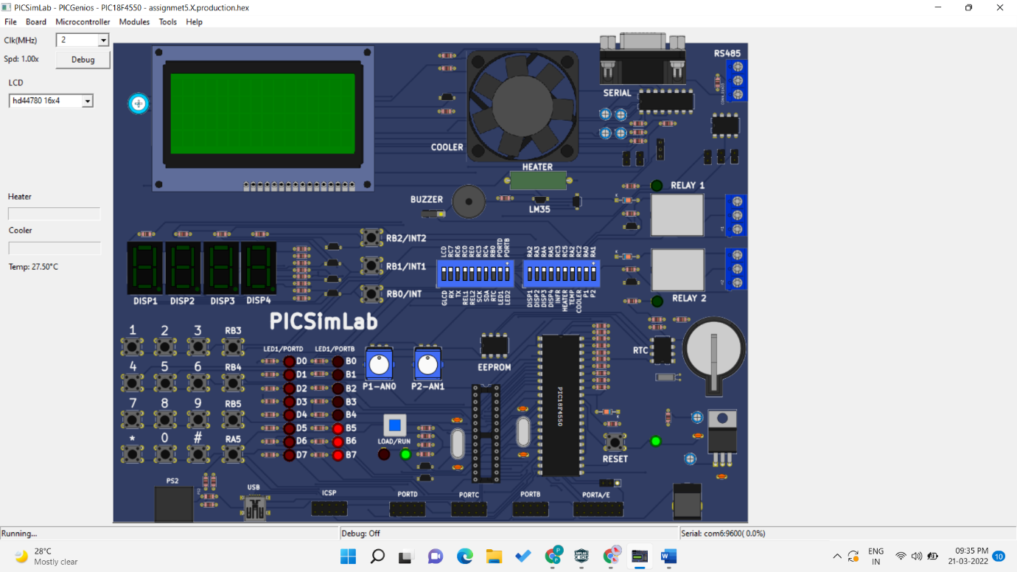

B]PORTD=55 AND AA

